Computer vision 1

Homework 4

姓名 ： 蘇宛琳

系所 ： 電信所碩一

學號 ： R05942060

指導教授 ： 傅楸善老師

Computer Vision Report – Homework 4

R05942060 蘇宛琳

Question : Write programs which do binary morphological dilation, erosion, opening, closing, and hit-and-miss transform on a binary image

dilation, erosion, opening, closing => 35553 kernal

hit-and-miss transform => J-hit kernel, k-miss kernal

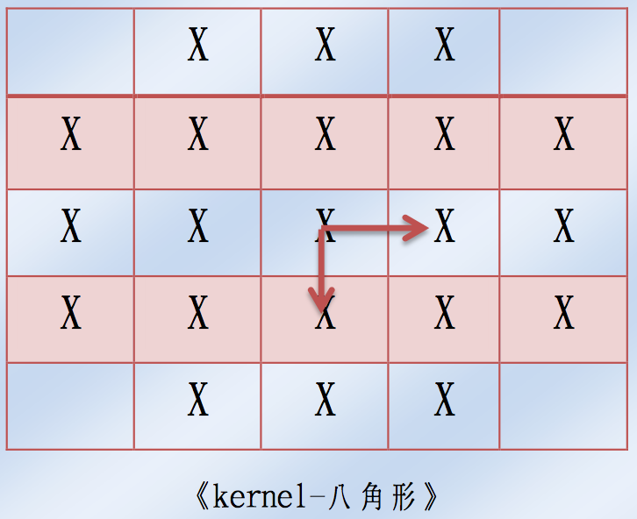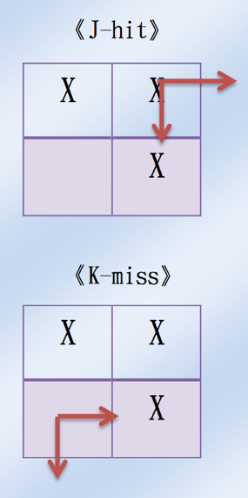

Write a program to do binary morphological dilation, erosion, opening, closing, and hit-and-miss transform

on a binary image

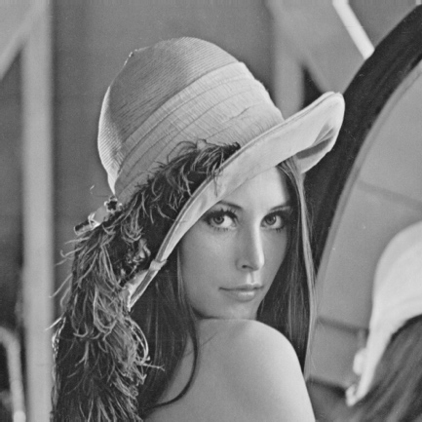 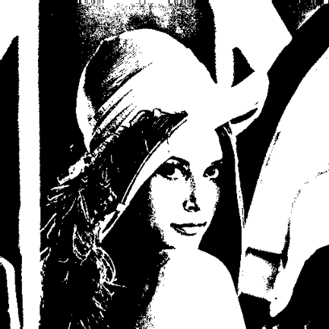

lena.bmp binarizelena.bmp

**Source code (Main code)**

clear;

close;

**Binaries LENA image**

%Binarize LENA image

LENA = imread('lena.bmp');

INFO = imfinfo('lena.bmp');

for x = 1:INFO.Height,

for y = 1:INFO.Width,

T = 128;

if LENA(x,y) > T;

LENA(x,y) = 255;

else

LENA(x,y) = 0;

end;

end;

end;

imwrite(LENA,'binarizelena.bmp');

**Kernel (35553 matrix)**

%Kernel(35553 matrix)

kerx = zeros(21,1);

kery = zeros(21,1);

kerx(1) = -2; kery(1) = -1; %(-2,-1)

kerx(2) = -2; kery(2) = 0; %(-2, 0)

kerx(3) = -2; kery(3) = 1; %(-2, 1)

kerx(4) = -1; kery(4) = -2; %(-1,-2)

kerx(5) = -1; kery(5) = -1; %(-1,-1)

kerx(6) = -1; kery(6) = 0; %(-1, 0)

kerx(7) = -1; kery(7) = 1; %(-1, 1)

kerx(8) = -1; kery(8) = 2; %(-1, 2)

kerx(9) = 0; kery(9) = -2; %( 0,-2)

kerx(10)= 0; kery(10) = -1; %( 0,-1)

kerx(11)= 0; kery(11)= 0; %( 0, 0)

kerx(12)= 0; kery(12)= 1; %( 0, 1)

kerx(13)= 0; kery(13)= 2; %( 0, 2)

kerx(14)= 1; kery(14)= -2; %( 1,-2)

kerx(15)= 1; kery(15)= -1; %( 1,-1)

kerx(16)= 1; kery(16)= 0; %( 1, 0)

kerx(17)= 1; kery(17)= 1; %( 1, 1)

kerx(18)= 1; kery(18)= 2; %( 1, 2)

kerx(19)= 2; kery(19)= -1; %( 2,-1)

kerx(20)= 2; kery(20)= 0; %( 2, 0)

kerx(21)= 2; kery(21)= 1; %( 2, 1)

**Kernel (J_hit)**

%J_hit

kerjx(1) = 0; kerjy(1) = 0; %( 0, 0)

kerjx(2) = 0; kerjy(2) =-1; %( 0,-1)

kerjx(3) = 1; kerjy(3) = 0; %( 1, 0)

**Kernel (k_miss)**

%k_miss

kerkx(1) =-1; kerky(1) = 0; %(-1, 0)

kerkx(2) =-1; kerky(2) = 1; %(-1, 1)

kerkx(3) = 0; kerky(3) = 1; %( 0, 1)

**Call function**

%Dilation

ImageDilation(LENA,kerx,kery,21,1);

%Erosion

ImageErosion(LENA,kerx,kery,21,1);

%Opening

ImageOpening(LENA,kerx,kery,21,1);

%Closing

ImageClosing(LENA,kerx,kery,21,1);

%Hit_Miss

ImageHitMiss(LENA,kerjx,kerjy,kerkx,kerky,3,3,1);

**ImageDilation function**

function output = ImageDilation(input,kerx,kery,n,showImage)

[Image_width,Image_height] = size(input);

for i = 1:Image_height,

for j = 1:Image_width,

if input(i,j) == 255,

for k = 1:n;

px= i + kerx(k);

py= j + kery(k);

if px>=1 && py>=1 && px <= Image_width && py <=

Image_height;

output(px,py) = 255;

end;

end;

end;

end;

end;

if ~exist('showImage') showImage=0;

end

if showImage~=0;

imwrite(output,'dilationLENA.bmp')

end

 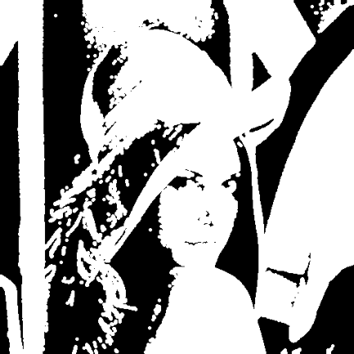

binarizelena.bmp dilationlena.bmp

**ImageErosion function**

function output1 = ImageErosion(input1,kerx,kery,n,showImage)

[Image_width,Image_height] = size(input1);

for i = 1:Image_height,

for j = 1:Image_width,

contain = 1;

if contain == 1

for k=1:n,

px= i + kerx(k);

py= j + kery(k);

if px < 1 || py < 1 || px > Image_width ||

py>Image_height || input1(px,py)==0,

contain = 0;

end;

end;

end;

if contain == 1,

output1(i,j) = 255;

else

output1(i,j) = 0;

end;

end;

end;

if ~exist('showImage') showImage=0;

end

if showImage~=0;

imwrite(output1,'erosionLENA.bmp')

end

 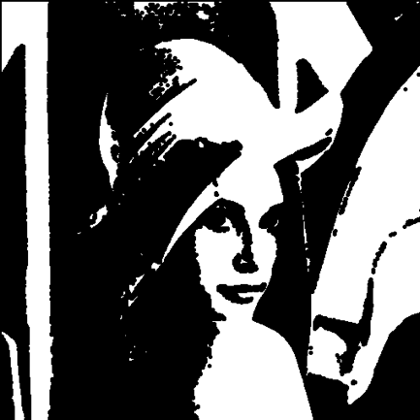

binarizelena.bmp erosionlena.bmp

**ImageOpening function**

function output2 = ImageOpening(input2,kerx,kery,n,showImage)

%Erosion

temp2 = ImageErosion(input2,kerx,kery,n);

%Dilation

output2 = ImageDilation(temp2,kerx,kery,n);

if ~exist('showImage') showImage=0;

end

if showImage~=0;

imwrite(output2,'openingLENA.bmp')

end

 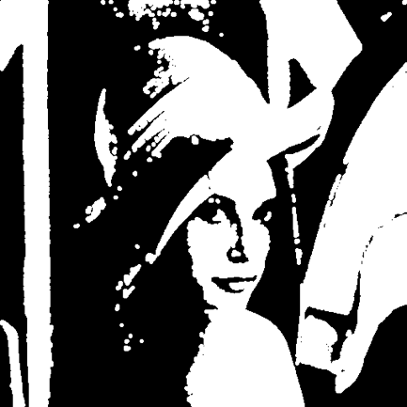

binarizelena.bmp openinglena.bmp

**ImageClosing function**

function output3 = ImageClosing(input3,kerx,kery,n,showImage)

%Dilation

temp3 = ImageDilation(input3,kerx,kery,n);

%Erosion

output3 = ImageErosion(temp3,kerx,kery,n);

if ~exist('showImage') showImage=0;

end

if showImage~=0;

imwrite(output3,'closingLENA.bmp')

end

 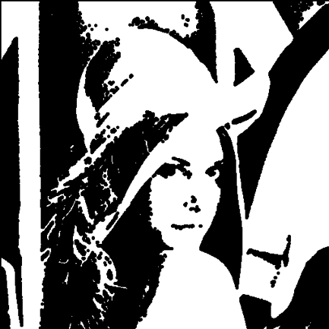

binarizelena.bmp closinglena.bmp

**ImageHitMiss function**

function output4 = ImageHitMiss(input4,kerjx,kerjy,kerkx,kerky,m,n,showImage)

[Image_width,Image_height] = size(input4);

for i = 1:Image_height,

for j = 1:Image_width,

comp(i,j) = 255 - input4(i,j);

end;

end;

% Erosion J-hit

image_hit=ImageErosion(input4,kerjx,kerjy,m);

% Erosion K-miss

image_miss=ImageErosion(comp,kerkx,kerky,n);

for i = 1:Image_height,

for j = 1:Image_width,

if image_hit(i,j)~=0 && image_miss(i,j)~=0

output4(i,j) = 255;

end;

end;

end;

if ~exist('showImage') showImage=0;

end

if showImage~=0;

imwrite(output4,'hitmissLENA.bmp')

end

 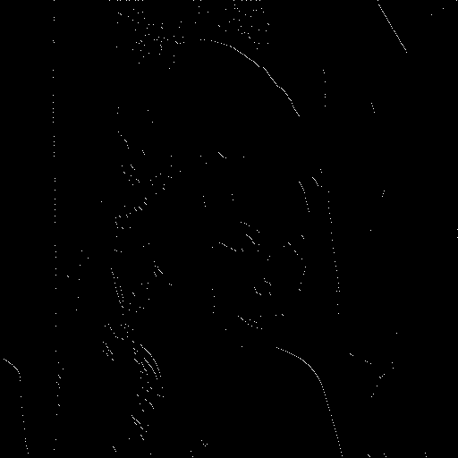

binarizelena.bmp hitmisslena.bmp